__________________________________________________________
EMORY UNIVERSITY SCHOOL OF MEDICINE

DEPARTMENT OF CELL BIOLOGY

__________________________________________________________

“Tuning centrosome activity
to ensure genome stability”

Presented by

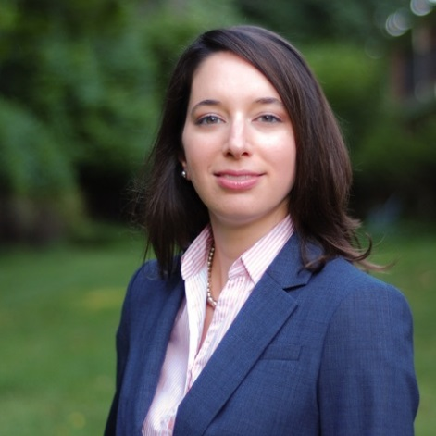

Dorothy Lerit, Ph.D.
FACULTY CANDIDATE
National Heart, Lung and Blood Institute
National Institutes of Health

Wednesday, February 17, 2016
4:00PM

Whitehead Biomedical Research Building, Room 400

Light Refreshments served at 3:30PM

